**Exercise 5 – Angular Exercises**

**Name:** Badri MSV **Roll No:** 195002017

**Subject:** UIT1611 – Web Programming Lab **Faculty:** Dr. S. Sasirekha

**Date:**

**Aim:**

5a. Simple Calculator using AngularJS

**Code:**

**index.html**

<!DOCTYPE html>

<html>

<head>

    <title>JS Calculator</title>

    <meta charset="UTF-8">

    <link rel="stylesheet" href="styles.css">

    <script src="https://ajax.googleapis.com/ajax/libs/angularjs/1.8.2/angular.min.js"></script>

    <script src="app.js"></script>

</head>

<body ng-app="calcApp" ng-controller="arithmeticController">

    <h1>Basic Calculator</h1>

    <div class="calc-container">

        <input type="text" id="display" value="{{ expr }}" ng-model="expr">

        <button ng-click="modifyExpr('')">C</button>

        <button></button>

        <button></button>

        <button ng-click="modifyExpr('/')">/</button>

        <button ng-click="modifyExpr('7')">7</button>

        <button ng-click="modifyExpr('8')">8</button>

        <button ng-click="modifyExpr('9')">9</button>

        <button ng-click="modifyExpr('*')">*</button>

        <button ng-click="modifyExpr('4')">4</button>

        <button ng-click="modifyExpr('5')">5</button>

        <button ng-click="modifyExpr('6')">6</button>

        <button ng-click="modifyExpr('-')">-</button>

        <button ng-click="modifyExpr('1')">1</button>

        <button ng-click="modifyExpr('2')">2</button>

        <button ng-click="modifyExpr('3')">3</button>

        <button ng-click="modifyExpr('+')">+</button>

        <button ng-click="modifyExpr('.')">.</button>

        <button ng-click="modifyExpr('0')">0</button>

        <button ng-click="modifyExpr('<')">&lt</button>

        <button ng-click="evaluate()">=</button>

    </div>

</body>

</html>

**app.js**

// create module

var calcApp = angular.module('calcApp',[]);

// create controller

calcApp.controller('arithmeticController', ['$scope', function($scope) {

    $scope.expr = "";

    $scope.modifyExpr = function(a) {

        if (a == '') {

            $scope.expr = '';

        }

        else if (a == '<') {

            $scope.expr = $scope.expr.slice(0,-1);

        }

        else {

            $scope.expr += a;

            // console.log($scope.expr);

        }

    }

    $scope.evaluate = function() {

        try {

            $scope.expr = Function('return ' + $scope.expr + ';')().toString();

        }

        catch(e) {

            $scope.expr = "Error!"

        }

    }

}])

**styles.css**

@import url('https://fonts.googleapis.com/css2?family=Noto+Sans+Mono:wght@300&display=swap');

body {

    font-family: 'Roboto';

}

.calc-container {

    width: fit-content;

    display: grid;

    grid-template-columns: repeat(4, 100px);

    /* border: 5px solid black; */

}

button, #display {

    font-family: inherit;

    font-size: large;

}

#display {

    grid-column-start: 1;

    grid-column-end: 5;

}

**Output:**

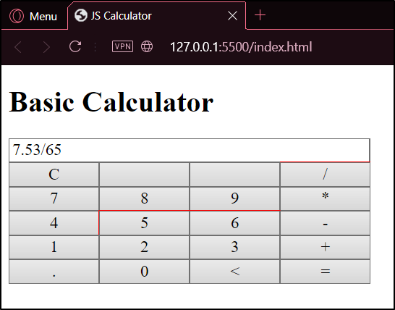 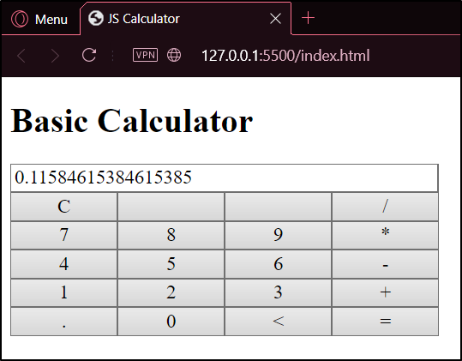

**Aim:**

5b. Angular program to implement Components, and Controllers

**Code:**

**sample.html**

<html>

<head>

    <script src="https://ajax.googleapis.com/ajax/libs/angularjs/1.6.9/angular.min.js"></script>

    <script src="c.js"></script>

</head>

<body>

    <div ng-app="myApp">

        <processor></processor>

    </div>

</body>

</html>

**c.js**

var myApp = angular.module("myApp", []);

myApp.component("processor", {

    template: `

    Enter your Name: <input type="text" ng-model="$ctrl.name"></input>

    <button ng-click = "$ctrl.upper()">Click here to Capitalize.</button>

    <br>

    <p>Your name is {{$ctrl.name}}</p>

    `,

    controller: function() {

        this.name = "someone";

        this.upper = function() {

            this.name = this.name.toUpperCase();

        }

    }

});

**Output:**

*­­Before on-click event:*

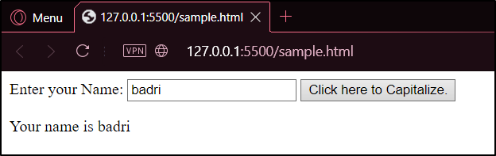

*After on-click event:*

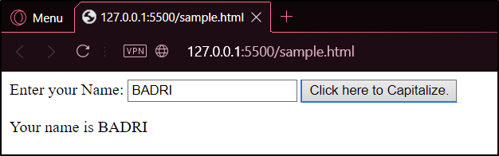

**Aim:**

5c. Angular program to implement search to filter items and services

**Code:**

**basenav.html**

<!DOCTYPE html>

<html>

    <head>

        <title>Musicophile</title>

        <link rel="stylesheet" href="index.css">

        <script src="https://ajax.googleapis.com/ajax/libs/angularjs/1.6.9/angular.min.js"></script>

        <script src="https://ajax.googleapis.com/ajax/libs/angularjs/1.6.9/angular-route.js"></script>

        <script src="index.js"></script>

    </head>

    <body ng-app="myApp">

        <nav>

            <a href="#!">Home</a>

            <a href="#!new">Enter New Music</a>

            <a href="#!filter">Edit Playlist</a>

        </nav>

        <div ng-view></div>

    </body>

</html>

**new.html**

<div class="musicform" ng-controller="myController">

    <h2>Enter New Music:</h2>

    <table cellspacing="5px" cellpadding="5px">

        <tr>

            <th>

                <label for="songname">Song Name:</label>

            </th>

            <td>

                <input type="text" ng-model="newmusic.name" id="songname" required>

            </td>

        </tr>

        <tr>

            <th>

                <label for="songauthor">Song Author:</label>

            </th>

            <td>

                <input type="text" ng-model="newmusic.author" id="songauthor" required>

            </td>

        </tr>

        <tr>

            <th>

                <label for="songgenre">Song Genre:</label>

            </th>

            <td>

                <input type="text" ng-model="newmusic.genre" id="songgenre" required>

            </td>

        </tr>

        <tr>

            <td colspan="2" class="center">

                <button ng-click="addMusic()">Add Music</button>

            </td>

        </tr>

    </table>

    <ul>

        <li ng-repeat="x in musiclist"><b>{{x.name}}</b> - by <i>{{x.author}}</i> ({{x.genre}})</li>

    </ul>

</div>

**filter.html**

<div ng-controller="filterController">

    <input type="text" ng-model="filterinput">

    <ul>

        <li ng-repeat="x in musiclist | filter: filterinput"><b>{{x.name}}</b> - by <i>{{x.author}}</i> ({{x.genre}})</li>

    </ul>

</div>

**index.js**

var myApp = angular.module("myApp", ["ngRoute"]);

myApp.config(function($routeProvider){

    $routeProvider

    .when("/", {

        template: "<h1>Hello !</h1>"

    })

    .when("/new", {

        templateUrl: "new.html"

    })

    .when("/filter", {

        templateUrl: "filter.html"

    });

});

myApp.factory("musicFactory", function(){

    return [

        {name: "Just the Truth", author: "Minami Kuribayashi", genre: "J-Pop"},

        {name: "I'm Not Sad, You're Sad", author: "Rachel Bloom", genre: "Indie"},

        {name: "Bury the Light", author: "DMC", genre: "Rock"},

        {name: "Just the Two of Us", author: "Grover Washington", genre: "Melody"},

        {name: "Stay Stay Stay", author: "Taylor Swift", genre: "Pop"}

    ];

});

myApp.service("addMusicService", function(){

    this.add = function(mainList, newmusic){

        var newMusicObject = {name: newmusic.name, author: newmusic.author, genre: newmusic.genre};

        mainList.push(newMusicObject);

    };

});

myApp.controller("myController", ['$scope', 'addMusicService', 'musicFactory', function($scope,addMusicService, musicFactory){

    $scope.musiclist = musicFactory;

    $scope.addMusic = function(){

        addMusicService.add($scope.musiclist, $scope.newmusic);

        $scope.newmusic.name="";

        $scope.newmusic.author="";

        $scope.newmusic.genre="";

    };

}]);

myApp.controller("filterController",['$scope', 'musicFactory', function($scope,musicFactory){

    $scope.musiclist = musicFactory;

}]);

/* $scope.musiclist.push($scope.newMusic); */

**index.css**

.center{

    text-align: center;

}

h2{

    text-align: center;

}

table{

    border: 1px;

    border-style: solid;

    border-radius: 10px;

    margin: auto;

}

input{

    border-radius: 25px;

}

html, body{

    height: 100%;

}

* {

    box-sizing: border-box;

}

**Output:**

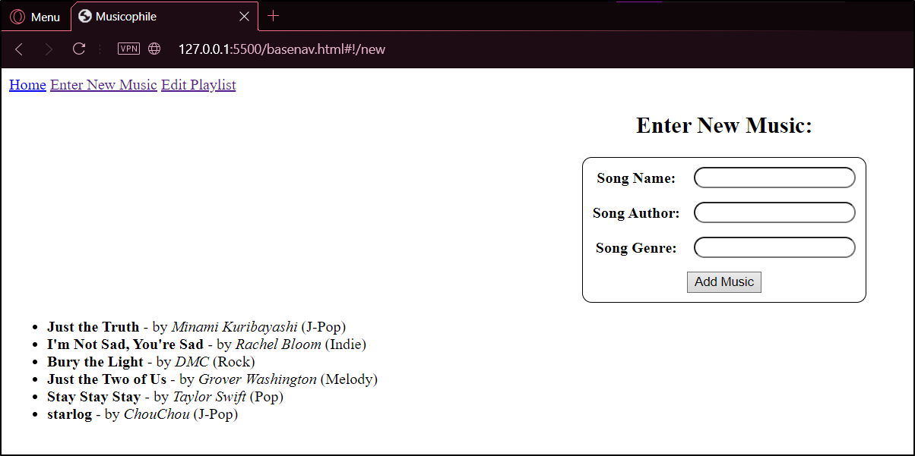

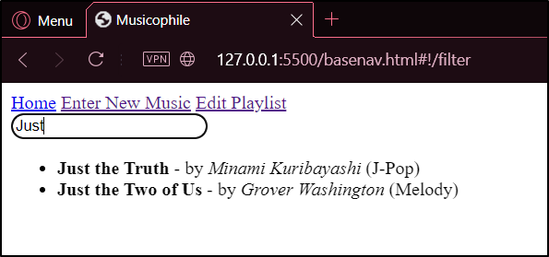 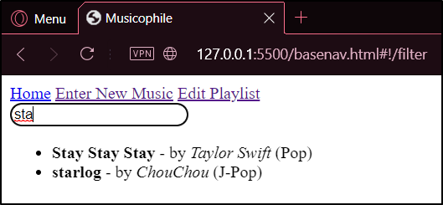

**Aim:**

5d. Form Validation using AngularJS

**Code:**

<!doctye html>

<html lang="en">

    <head>

        <title>Form Validation using Angular JS</title>

        <script src="https://ajax.googleapis.com/ajax/libs/angularjs/1.8.2/angular.min.js"></script>

        <link rel="stylesheet" type="text/css" href="ex5dstyle.css">

    </head>

    <body ng-app="myApp">

        <h3>Student Form</h3>

        <fieldset class="container">

        <legend>Basic Details of a student</legend>

        <form name="myForm">

                <div class="{{myForm.name1.$valid}}">

                    <label for="name">Name</label>

                    <input type="text" ng-model="name1"ng-pattern="/^[a-zA-Z\s]*$/" name="name1" required>

                </div>

                <br>

                <br>

                <div class="{{myForm.email.$valid}}">

                    <label for="email">Email</label>

                    <input type="email" id="email" ng-model="email" name="email" required>

                </div>

                <br>

                <br>

                <div class="{{myForm.addr1.$valid}}">

                    <label for="addr1">Address line -1</label>

                    <input type="text" id="addr1" ng-model="addr1" name="addr1" required>

                </div>

                <br>

                <br>

                <div class="{{myForm.addr2.$valid}}">

                    <label for="addr2">Address Line -2</label>

                    <input type="text" id="addr2" ng-model="addr2" name="addr2" required>

                </div>

                <br>

                <br>

                <div class="{{myForm.xscore.$valid}}">

                    <label for="xscore">10th CGPA</label>

                    <input type="number" id="xscore" step="0.2" ng-model="xscore" name="xscore" max="10" required>

                </div>

                <br>

                <br>

                <div class="{{myForm.xiiscore.$valid}}">

                    <label for="xiiscore">12th Percentage</label>

                    <input type="number" id="xiiscore" step="0.2" ng-model="xiiscore" name="xiiscore" max="100" required>

                </div>

                <br>

                <br>

                <br>

                <button type="submit">Submit</button>

                <br>

            </form>

        </fieldset>

    </body>

    <script>

        app=angular.module("myApp",[]);

    </script>

</html>

**css**

body{

    font-family: Roboto;

}

.container{

    width: 40%;

}

.true{

    border: 5px solid green;

    border-radius: 25px;

    padding: 10px;

}

.false{

    border: 5px solid red;

    border-radius: 25px;

    padding: 10px;

}

**Output:**

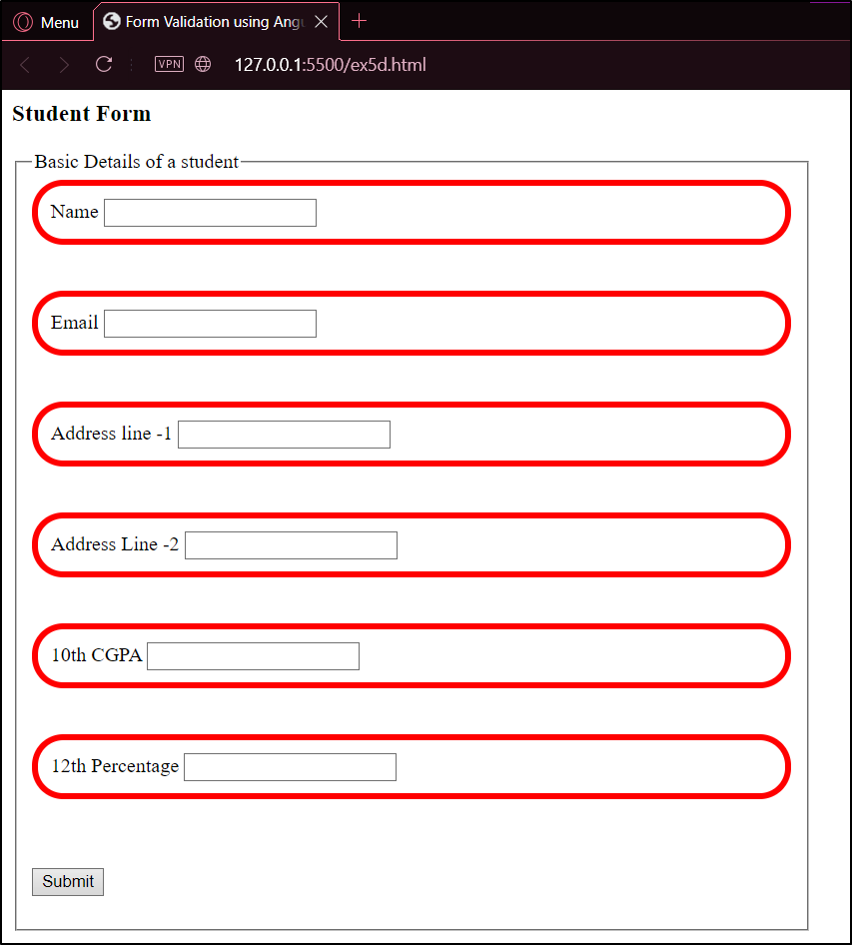 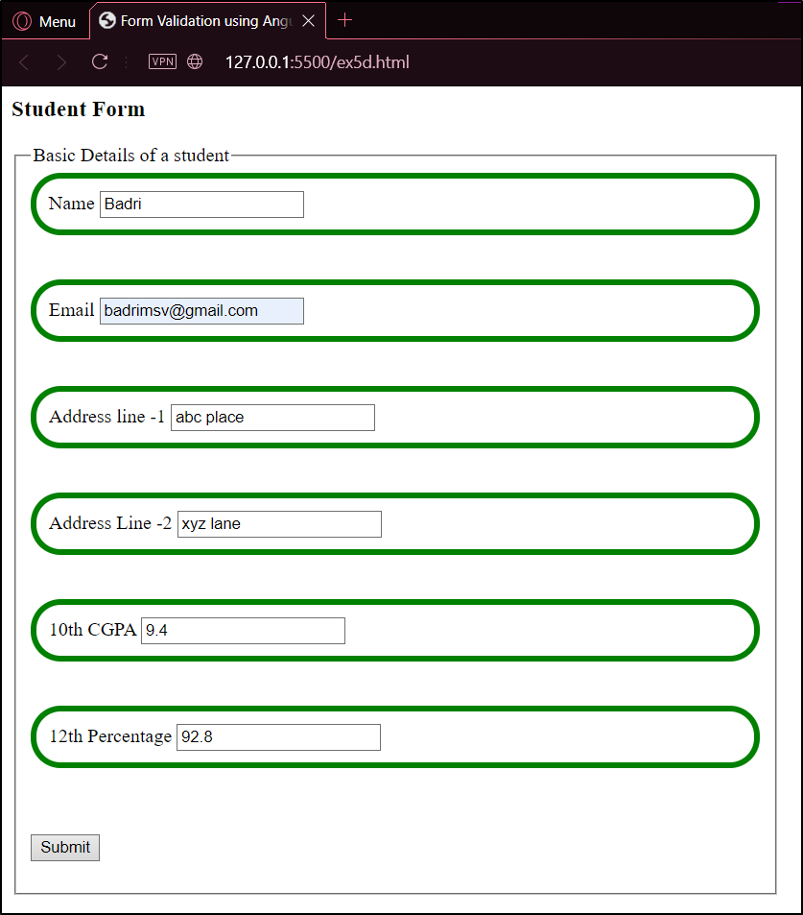

**Result:**

Thus, the given programs were written and executed successfully and Angular JS was learnt.